

Audio Network ~ How To

Audio Network and the RBC are providing schools and partner LEAs and Colleges with free access to thousands of production music files over the national education networks. Files can be used creatively for curriculum work and guidance on getting copyright permissions to use work in the public domain through a one-step process is available.

The How To document gives a quick introduction in how to Search, Select and Download music files. This document should be read in conjunction with the Copyright document and the FAQs to get the full picture of using the Audio Network music in education. Further information links are on the final page.

The files are only available free if you are using a computer connected to the National Education Network, from an RBC connected school or are an RBC Audio Network partner. To get the free files from the Education Licence website simply go to

http:audio.lgfl.org.uk

:: there’s no www or backslashes in the address ::
:: no password is required ::

If you try to access this url from an unconnected computer you will go to a London Grid for Learning (LGfL) customer page…because LGfL hosts the education Licence website and you won’t get to the files.

The Schools Licence website works in a similar way to ‘Amazon’...letting you search titles and listen to them and collecting your choices into a shopping trolley. In this case you have immediate customer satisfaction as you can download the files straight away and you don’t even have to pay!

Step 1, Searching
The home page is also the main search page.

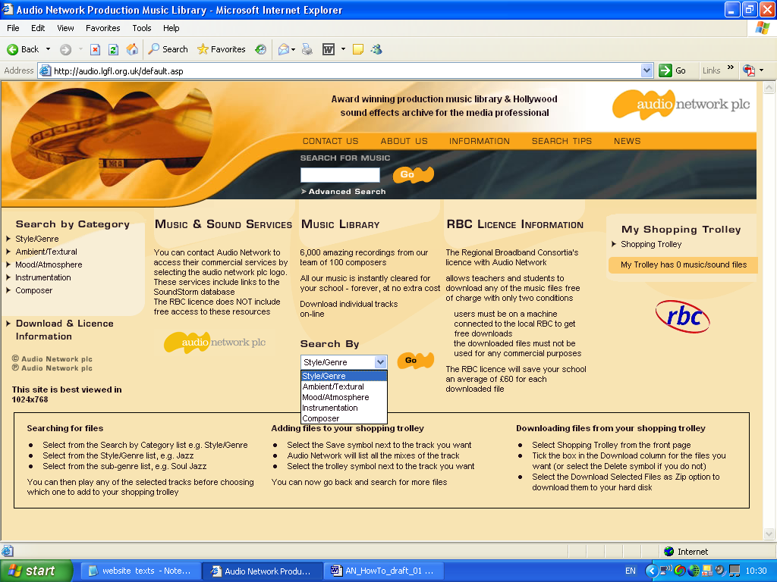
Drop down menu
Choose from:
:: Style/genre
:: Ambient/Textural
:: Mood/Atmosphere
:: Instrumentation
:: Composer
❶
❷
❸

This is the home page. The music files are arranged under four categories, each with a longer list of subcategories. The categories cross-index the titles and types of music.

Choose a category from the main menu ❶ , the drop down menu ❷ or the keyword box ❸.

Advanced Searching

To use advanced search - click on ‘> Advanced Search’ - it’s just under the keyword search box, top centre ❶

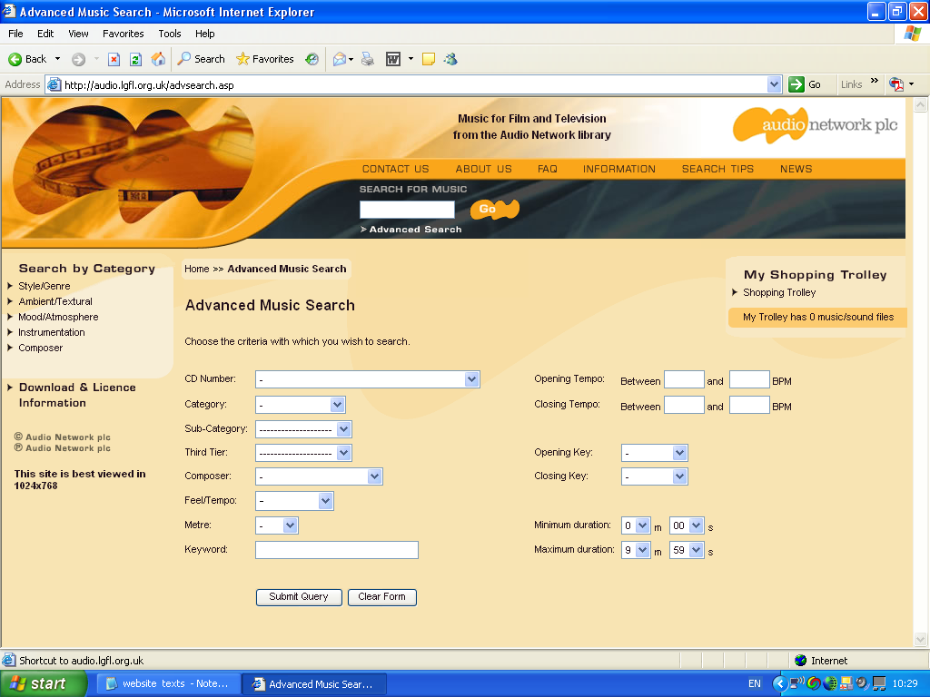
Search using:
:: CD number
:: Metre (time signature)
:: Tempo
:: Key
:: Composer
:: Duration
:: Style or genre
:: Keyword
Many of the search terms have drops down menus to make choices from.
❷

Step 2, Selecting

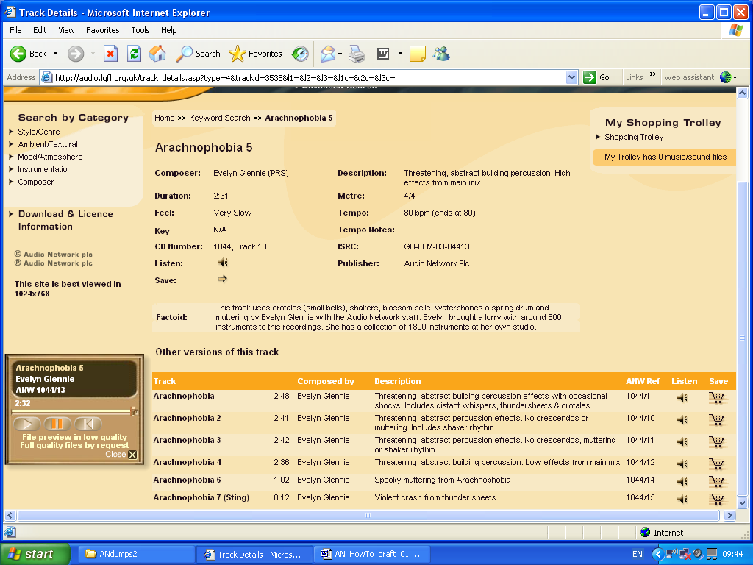
‘Save’ icon
The Audio Player pops up automatically when you click on the ‘Listen’ icon.
Player
The top section of the page has full details of the selected track. In this case the very scary ‘Arachnophobia’ composed and performed by Evelyn Glennie.

The page lists details of the composer; duration (in minutes and seconds), a description, and sometimes a ‘factoid’ about the recording – in this case it lists the types of instruments used in the recording. It also states the musical metre of the piece and the tempo in beats per minute (bpm). The publisher is Audio Network and you can also note the AN reference number.

The ISRC number confirms that the track has been recorded and registered to the International Standard Recording Code. For vocational courses there is more on this at www.ifpi.org/isrc/isrc_handbook.html .

To preview a track press the Listen icon

On the left is the audio player that appears automatically and lets you start, pause and replay the track. You can’t download or save the track from this player. The player will not install anything permanent on your computer.

The bottom section of the page lists the versions, if any, that are available of the track - in this case there are 7 versions taken from the ‘main mix’ including a ‘sting’ - a very short piece - and section with and without crescendos (the very loud parts). The versions provide choices for the film/media producer to work with. To choose a version click on its title and it will open in the top half of the page showing all the details of the track.

To choose the track click on the Save icon

Raising awareness ~ music and language
There is a lot of detail on the selection page that a teacher can use with a whole class or as the opportunity arises with individuals and working groups.
- Identifying instruments and sounds.
- Can you hear the differences between versions?
- Timing of tracks; identifying the metre.
- Which bits would you take from the ‘main mix’ to make a ‘sting’?
- The descriptions are rich in language use… ask for ideas for a title; what scene in what type of film or game? Adjectives for the sounds? Writing your own description.
‘Listen’ icon

Step 3, Downloading
The files you have selected are listed. You can download or delete selected files or use the back button to return to the select pages and carry on selecting more files.

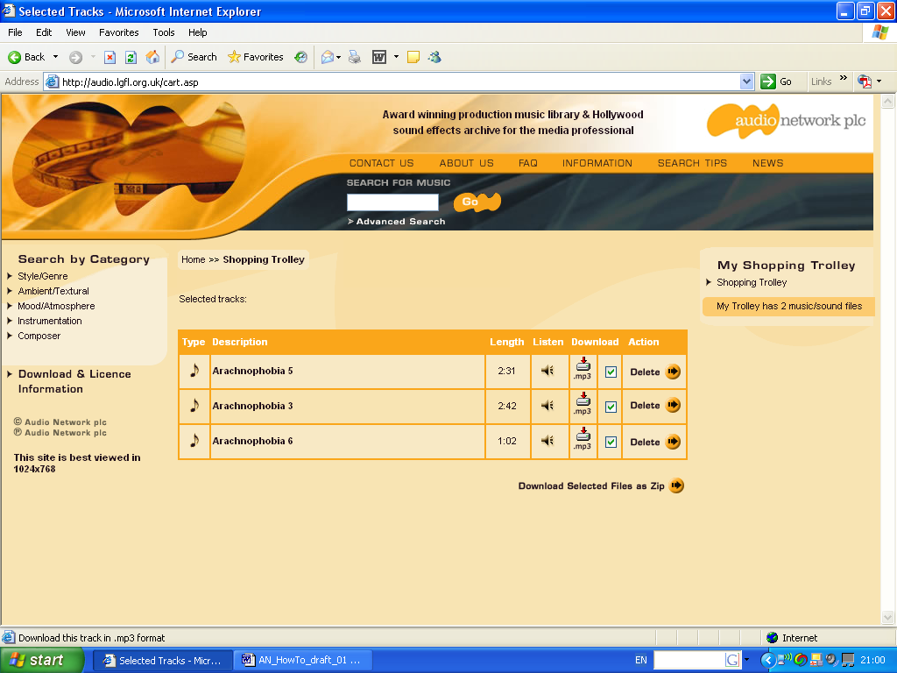
❶ Don’t forget to check ✓the empty box!

Delete if you don’t want a file or have chosen the same one twice.
Download Selected Files as Zip if you have a number of files
Click on Mp3
if you want a single file

To download

- Click on the empty box second from the right and a green tick appears ✓.

❷ Click on the button and the Zip file collects all the selected files in one go.

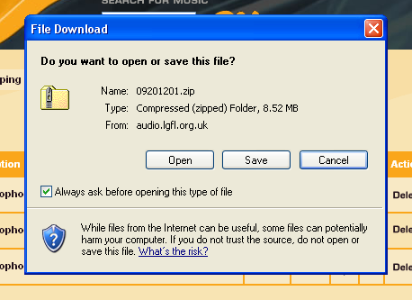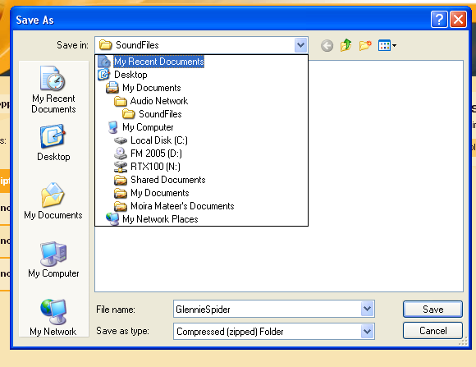
‘File Download’ dialogue box appears…

- Click on ‘Save’ button

‘Save As’ dialogue box appears…

Rename the file name…

Choose the folder you want to store the files in.

❹ Click on ‘Save’ button

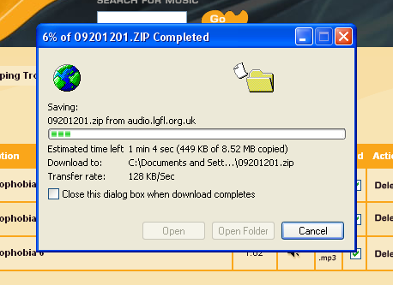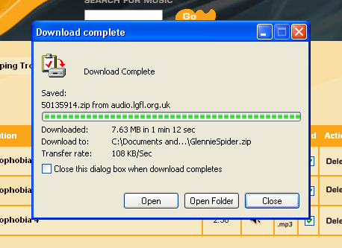
‘Saving progress’ dialogue box appears…

Sit back and watch…

‘Download Complete’ dialogue box appears…

❺ Click on ‘Open Folder’

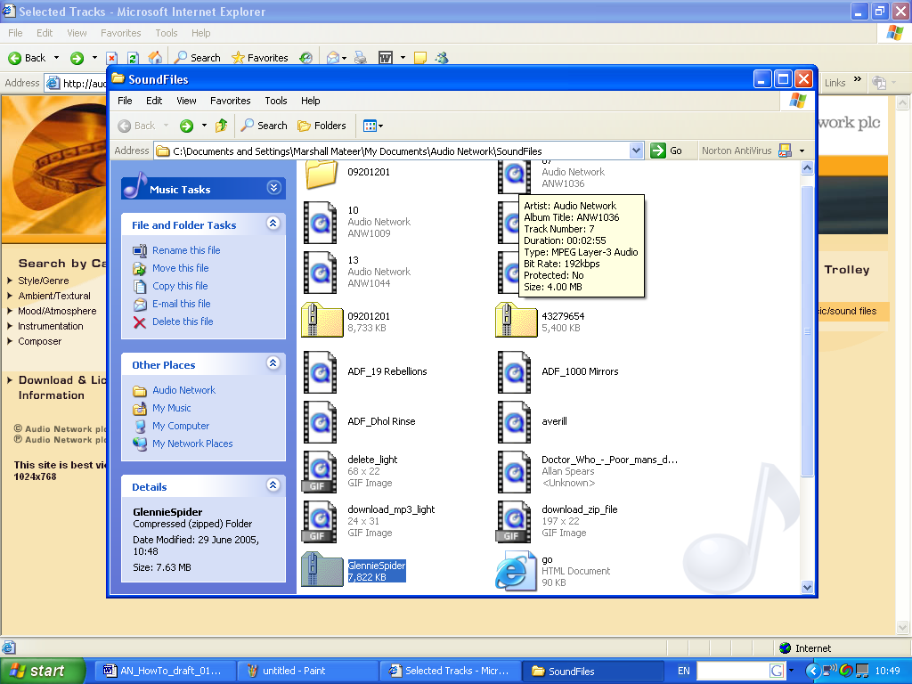
❻ The ‘Glennie Spider Zip (or compressed) file is here. The icon is a folder with a zip on it.

Next step is to unzip it, name and store the separate files.

Different computers (operating systems) work slightly differently in how you store the files and in the different icons they use.
These pictures are from a computer using Microsoft XP and the icons are for the ‘Quicktime’ player.

The next step is to “unzip” the folder and store the separate audio files.

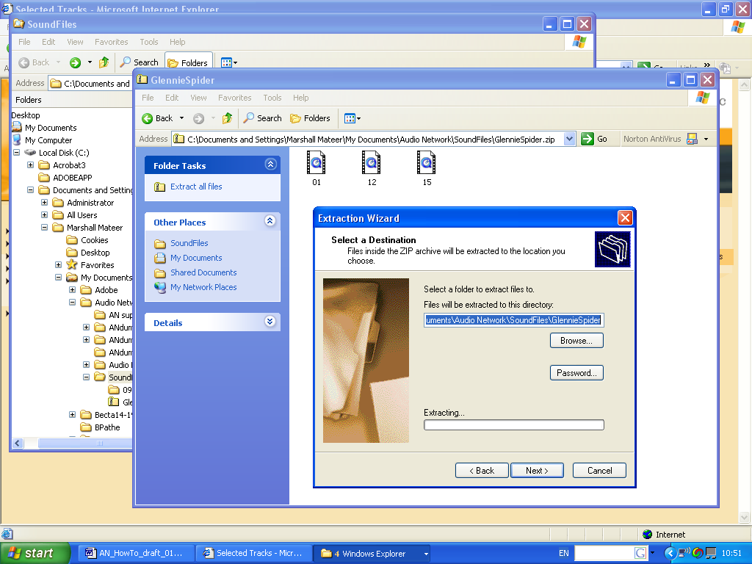
The three files that were downloaded are visible but NOT stored yet.
The Unzip wizard…just press ‘next’. You have the opportunity to choose the folder to save the files in.
❼ Unzipping the files

In this case the unzip software is built into the computer’s software and a wizard takes you through the process.

With some computers you will need assistance to install or locate a separate ‘unzip’ programme to do this task. It’s not difficult, just different, depending on what computer and software you have.

- The audio files

After unzipping the files will change their names to include the track number and the AN CD number like this...

12
Audio Network
1044

i.e. Track 12 on CD 1044.

Use the Advanced Search function of the website to locate the files using this data.

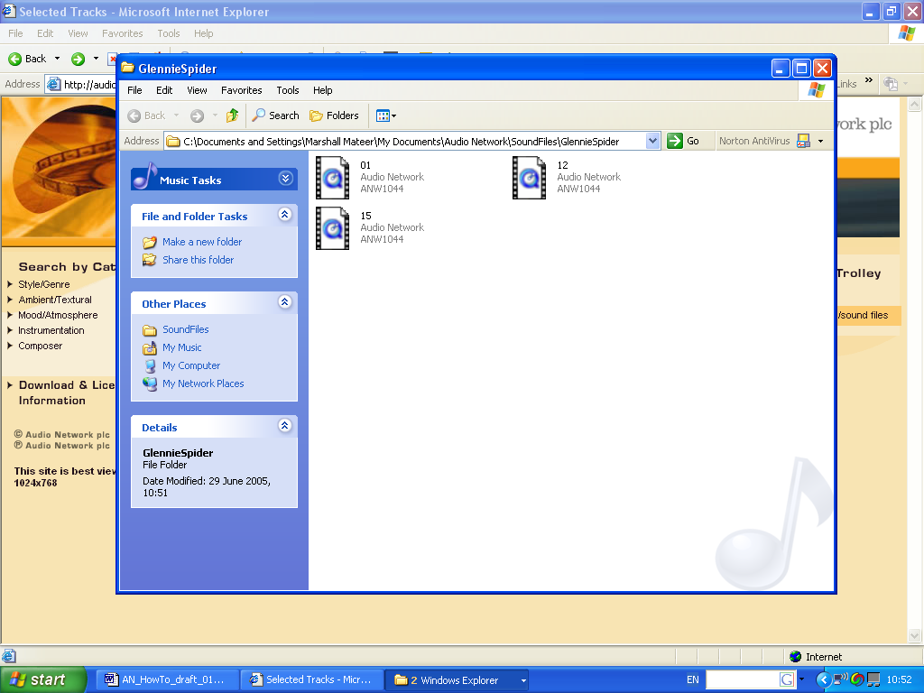
:: Right Click on the file icon.
:: Choose ‘Properties’ from the menu
:: Choose ‘Summary’ from the tab
:: Click on ‘Advanced’
and …
you will see a full set of data about the file.

The files you download are in MP3 format and will play on either Quick Time or Windows Media players and can be imported into most of the popular audio and video software packages.

Further help?

Further help with unzipping the files and working with them will have to come from your ICT co-ordinator or local support to suit your computer, its operating system and the software you have.

Locating a track.
The Audio Network catalogue is available as themed sets on CD and CD Number is used as a basic reference in the database. Every file you download has a track number and CD reference.
For instance:
1
Audio Network
1044
means track 1 on CD 1044

To locate the track and file number if a file
has been renamed
:: Right Click on the file icon.
:: Choose ‘Properties’ from the menu
:: Choose ‘Summary’ from the tab
:: Click on ‘Advanced’
and you will see a full set of data about the file.

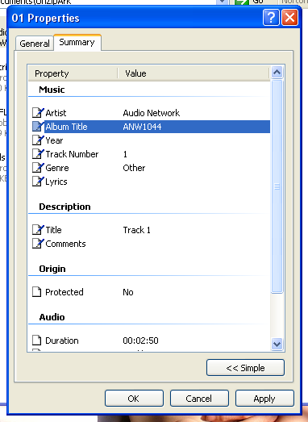

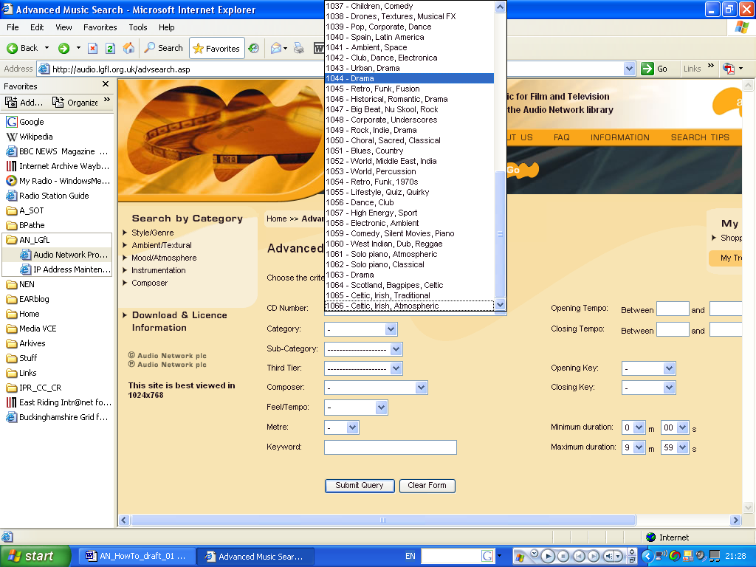
If you know the CD and track number go to the Advanced Search option from the home Page (see Step 1).

Click on CD Number
and a drop down (or in this case drop up) menu appears listing all the CDs by theme name and number reference. Choose the number you want and it takes you to the details of the tracks.

Working at Home
The Audio Network commercial site is at www.audiolicense.net

The education website is similar in function, look and feel but there are some significant differences: e.g. sound effects are only available from www.audiolicense.net but at a charge (it’s a few £s each). The commercial site also includes a wider selection of music compositions and the additional services are different. CD numbers 1001 until 1066 inclusive are the ones on the School Service - you can find them through the advanced search - see above - which lets you use the site at home to preview files and plan work.

Glossary
Main track: the whole thing

Underscore: an underscore is a mix of the main track where the featured instrument, voice or melody is removed. Having tracks available in a variety of forms and mixes gives the user more options and enables them to edit tracks to picture more creatively or create a brand or identity throughout a production.

Mixes: sometimes a different mix of a track will make a huge difference to the feel. for example, some of the tracks will appear as full versions, underscores, then simply the rhythm section or the strings for example. This all helps the editor work more creatively with music.

Cuts: these are cutdown lengths. Some users need tracks cut to 60 second or 30 second lengths to make the music easy to use on commercials or websites.

Stings: very short (10 seconds or less) pieces of music for going into a commercial break or to be used for changing scenes on film. They are also called bumpers, bridges or links

Versions: generally refers to different mixes

Noise: the extraneous sounds produced by the recording process.

Level: the record sound (as seen on a display with peaks and troughs) – volume for the elements.

Donut: a track in which a voice/lyrics section is set in the centre of an instrumental track.

Cue Sheets: cue sheets record ,title, timing, duration, order, copyright information and type of music use of music in a production. They are used to help the producer ensure that all music usage has been cleared with the various copyright owners and are used by performing rights societies to allocate royalties.

Featured music: music that forms an integral part of a production, e.g. actors responding to or referring to the music used in a particular scene.

Background music: music that simply creates a mood or atmosphere and is not featured music.

SFX: short for sound effects. Which in our case “we have not got”…though you can buy them on the commercial site.

Further information

- Schools in the West Midlands should contact their LEA or info@wmnet.org.uk
- Schools elsewhere in England should contact their RBC or LEA - a full RBC list is at http://www.shapesoftime.net
- Schools in Scotland should contact LTS and in N.Ireland, C2K.
- Schools in IOM, Jersey and Guernsey also have access to this service.
- FE Colleges in England should contact their RBC; in other areas of the UK please email info@shapesoftime.net.

:: The Audio Network commercial site is at www.audiolicense.net

:: About Audio Network Schools Licence is at www.shapesoftime.net

:: email info@shapesoftime.net



The RBC Audio Network Education Licence
Supporting learning and creativity through the best in digital services

RBC/Audio Network PLC - some rights reserved, 2005

This document has been prepared by the RBCs and Audio Network - June 2005 - some rights reserved. You may customise this document to suit your RBC, LEA or school but please maintain the integrity of the information on using the Audio Network website and include the RBC and Audio Network logo – thank you.

