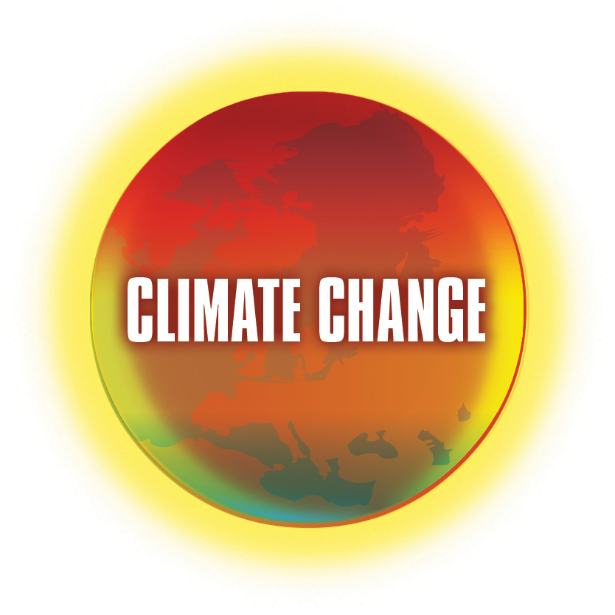 | Climate Change: “Ask the Expert”  School Resources  http://climatechange.wmnet.org.uk

The role of oceans in changing our climate:
with Professor Harry Bryden, University of Southampton

So that you can get the most out of the fantastic opportunity of questioning the experts we have assembled SOME of the popular evidence related to climate change that is available on the international web.
You can use this information as a foundation for your questions to the experts, as a support to your examination work and to increase your world knowledge on a major issue of our time.
If you use this information in your exam work it is really important that you acknowledge the original source; some of those people have been working on that data for many years.

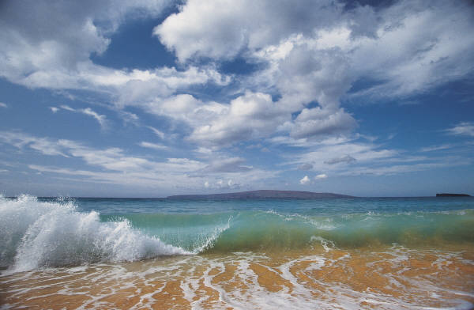

Source 1

Introduction
As land based animals homosapiens (you and me) ‘forget’ that 3/5 of the earth is covered with water. The evaporation from the oceans is blown to the land to give us our climatic rainfall; this together with the insulating properties of those vast bodies of water are major drivers in controlling the climate over the land, on which we as a species exist. It follows that any major change in those vast bodies of water will change the climate of our planet.
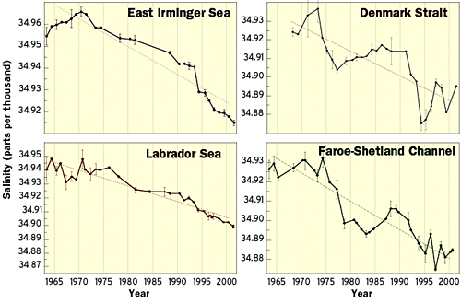

Effect on Temperature
The melting of the polar icecaps will mean a decrease in the water temperature in northern and southern latitudes.

* How will this reduction in global water temperature in those latitudes influence our planet’s ocean circulation, weather, species distribution and longevity?
Source 4

Ocean Conveyor Belt
The cold water of the North Atlantic; which has a lower salt content than water further south, sinks to the deep ocean and is pushed south. In the tropics that water warms, rises, becomes more saline and eventually is pushed north once more.
* How may this circulation of the earth’s ocean system be effected by climate change?

Source 2

Salinity
As the great polar ice-caps melt they will pump vast quantities of cold, fresh water into the oceans; this will result in a reduction in the salinity of the oceans. “We find that these changes have already led to sustained and widespread freshening of the deep ocean.”(3)
* How sustainable is this change? At which point are the ocean ecosystems irreversibly changed?

Sea Level Changes – LEDC’s
As sea levels across the world rise, coastal rice growing areas will not be able to support their existing massive populations, the land will simply disappear. Already the 20 year catastrophic flood interval has reduced to a 5 year frequency. The result of one flood? “600 dead and at least 30 million people homeless” (5) and that was one flood in one region.
* How should we respond to this new knowledge?
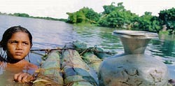

Source 6 © Trygve Bolstad/Panos Pictures

Sea Level Changes – MEDC’s
‘Counting the cost’ in 2005 the damage estimated from hurricane Katrina varied from between $100,000,000,000 and $200,000,000,000 (7). Jobs and income ceased to function, food supplies ceased, water and sewage disposal systems were destroyed, power supplies, communications, and health utilities were temporarily affected.
World oil prices rose as the coastal refineries ceased to provide for the USA.
* With rising sea levels how economically realistic is it to support human activity on the coast?
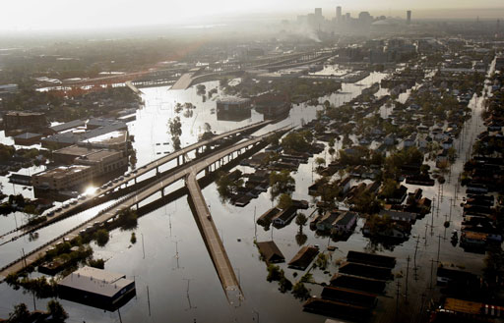

Source 8

Effect of Rising Sea Level on Freshwater Aquifers
As sea levels rise the groundwater will become contaminated with salt water (9). This will mean sources of fresh water will no longer be available in some areas.
* How extensive is the problem of increasing salination of coastal groundwater?

Carbon Sink
Our oceans are vast sinks that store atmospheric carbon dioxide. As the oceans heat up, their ability to store carbon dioxide will be reduced, thus the greenhouse effect will be increased. Estimates vary about how much CO2 passes through the ocean exchange, however one estimate calculates this process as 2, 000,000,000 tonnes of gas per year (10).
* Is it possible to build an accurate predictor of oceanic carbon exchange and of the precise relationship with global warming?

Effect on Fisheries
Changing oceanic temperatures and salinity will effect the distribution and density of phytoplankton and fish species. Cod rarity has been attributed not only to over fishing but also to changes in ocean temperature. (11)
* To what extent are these shifting patterns linked to catastrophic depletion?
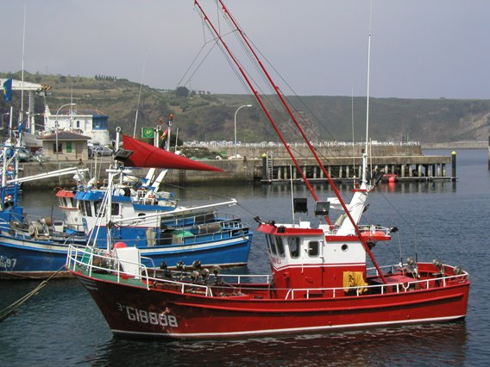

Source 12

Effect on Health
Rises in sea temperature may well exacerbate issues of public health. Water-borne diseases like cholera and malaria would be set to rise in line with rising temperature and sea levels. This particular problem would be concentrated in LEDC countries, which cannot afford a fully developed public healthcare program. In the USA deaths and serious illness from some mosquito borne diseases have been increasing (13). Algal blooms will affect water oxygen content and related toxic release into the ocean systems.
* Are governments recognizing, analyzing and responding to projected health needs?
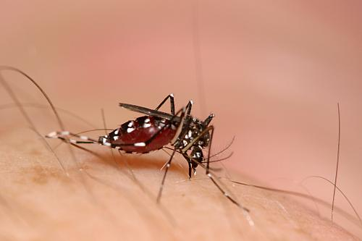
©1998-2003 Troy Bartlett

Source 14

Sources
- Beach in Northern Spain. Jan Ousby
- http://www.whoi.edu/
- http://asof.npolar.no/library/pdf/dicksonetal.pdf
- http://www.whoi.edu/institutes/occi/currenttopics/climatechange_wef_en3b.html
- http://www.scidev.net/Editorials/index.cfm?fuseaction=readEditorials&itemid=125&language=1
- http://www.peopleandplanet.net/doc.php?id=2152
- http://en.wikipedia.org/wiki/Hurricane%C2%A0Katrina
- http://www.wwltv.com/sharedcontent/breakingnews/slideshow/083005_dmnkatrina/1.html
- http://www.ucsusa.org/gulf/gcimpactwater.html
- http://www.nsc.org/ehc/climate/ccucla14.htm
- http://www.elements.nb.ca/theme/climate03/hugh/akagi.htm
- Spanish Fishing Fleet, Harold Ousby
- http://www.idph.state.il.us/envhealth/wnv.htm
- http://troyb.com/photo/index.htm

