 | Climate Change: “Ask the Expert”  School Resources  http://climatechange.wmnet.org.uk

Transport and climate change:
with Dr Lee Chapman, University of BIrmingham

So that you can get the most out of the fantastic opportunity of questioning the experts we have assembled SOME of the popular evidence related to climate change that is available on the international web.
You can use this information as a foundation for your questions to the experts, as a support to your examination work and to increase your world knowledge on a major issue of our time.
If you use this information in your exam work it is really important that you acknowledge the original source; some of those people have been working on that data for many years.

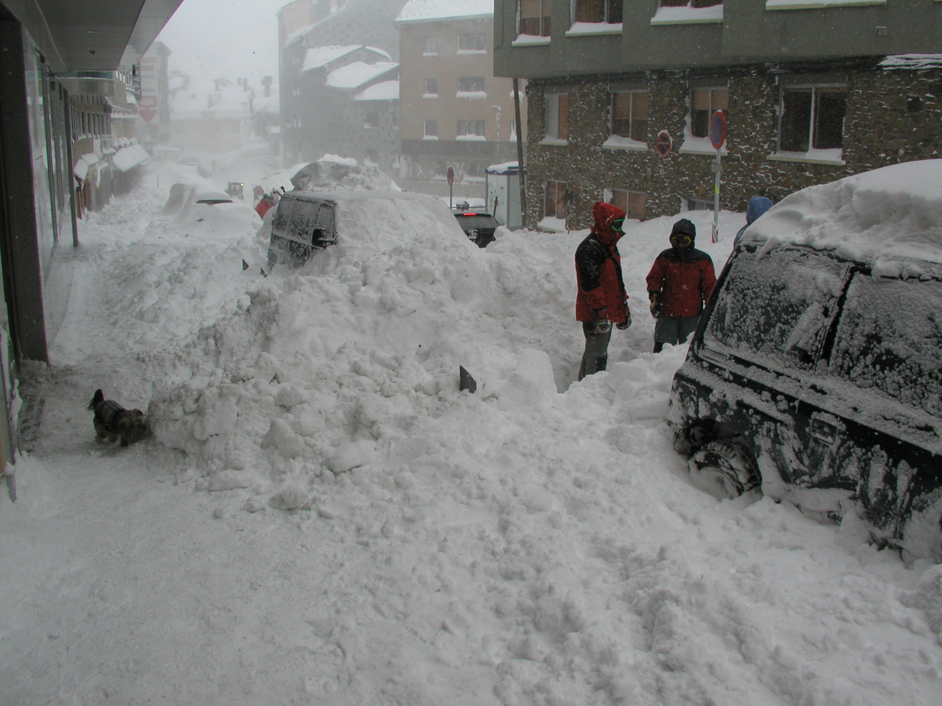
Source 1

Introduction
As climate change takes a grip, the transport infra structures on which global trade is dependant will be seriously interrupted. A degree of instability may well weaken world economies.
* How appropriate is road transport?

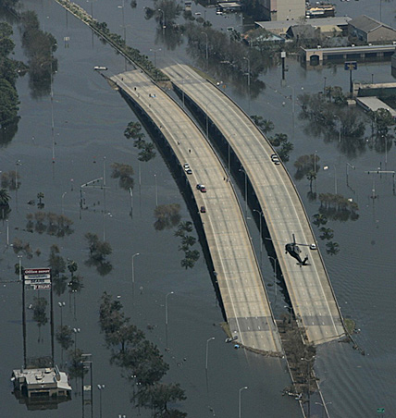
Source 2

Road systems and carbon dioxide emissions

a) MEDC’s
The USA emits 25% of world CO2; this translates to almost 9 kgs of CO2 pumped into the atmosphere for every 5 litres of fuel burned (Source 4) – The actual quantities of CO2 that all MEDC’s emit from the burning of petrol are incredible, and increasing.
China, as an emerging nation, will want to develop its road infrastructures in line with social and economic demands, to be comparable to MEDC’s – and that means an increase in CO2 emissions.
* How effectively are countries like the UK and USA using their wealth towards reducing global CO2 emissions?
* What will the impact of Hydrogen powered vehicles be on pollution? And how feasible is the Hydrogen powered motor vehicle?

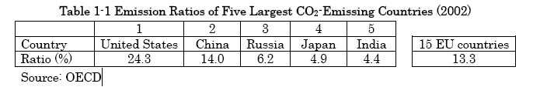
Source 3:OECD

b) LEDC’s
Population of USA 298 billion.
Population of China 1304 billion (Source 5)
At present motor vehicle use in LEDC’s is low. As economies like China continue to grow we can anticipate that they will produce more that four times the emissions of the USA, unless policies, technology and attitudes change. India has 1104 billion people, Indonesia 222 billion, Brazil 184 billion.
* Can you calculate the projected motor vehicle emissions of CO2 for those countries?
* In terms of natural resources how sustainable is that type of projection?

Food Miles

Source 6

We are increasingly reliant on the use of HGV’s to transport our food (Source 7). The movement of food goods by air has dramatically increased. Flooding, frost heave, rail buckling and the rising cost of fuel will a make changes in food supply and distribution an inevitability.
* How will a less predictable supply rate and increasing fuel costs influence prices?
* Will this impact on location of food sources?

Permafrost
Vast areas of the planet are subject to permafrost. As a permafrost region warms up it changes colour, becomes darker, absorbs more heat and the warming process accelerates. Whilst those areas do not support many people the impact of climate change does influence world transportation patterns. Oil pipelines, railway lines and road systems become disrupted.
* How essential on a global scale are sub arctic transport systems?

Source 8

Air travel and climate change
In the next 50 years we expect to quadruple the amount of aviation fuel burnt. This impact is comparable with that already discussed related to motor vehicle transport.
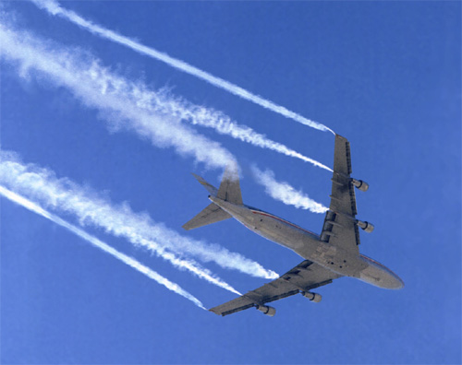

Source 9

The contrails of aircraft which we admire from the ground add to the greenhouse phenomena by producing high level cirrus cloud which in effect locks in CO2 emissions produced at ground level. One comparative study suggests this accounts for the total global warming we can measure (Source 10).
* What immediate efficiency measures could be implemented to reduce the use of aviation fuel?

Rail travel and climate change
Problems of excess heat, cold and flooding are similar to those of road transport. The question that must be addressed is just how efficient is rail transport in people and goods miles, and how convenient is it?
* Socially and economically how viable is rail transportation compared to road and air?
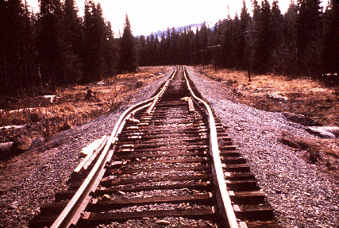

Source 11

Sea travel and climate change
Clearly all the lowland coastal infrastructure will be impacted by rising sea levels. So whilst the actual port may not be affected, indeed some ports may benefit through rising sea levels, transporting goods and people to the ports appears to be a major issue.
Where a region’s economic life is dependant on water transport, as in the Great Lakes area of North America then issues of siltation and water level are critical.
* What are the issues effecting the transport infrastructure of the Great Lakes region of North America

Sources | - www.wwltv.com/sharedcontent/breakingnews/slideshow/083005_dmnkatrina/30.html
- Harold Ousby Winter in Spain | - www.guardian.co.uk/waste/story/0,12188,1528964,00.html
- www.wwltv.com/sharedcontent/breakingnews/slideshow/083005_dmnkatrina/14.html | - www.ens-newswire.com/ens/dec2005/2005-12-20-03.asp
- www.japantransport.com/conferences/2005/11/seminar_report.pdf | - www.nasa.gov/centers/dryden/images/content/87006main_TF-2004-14_popup1.jpg
- www.eia.doe.gov/oiaf/1605/coefficients.html | - http://www.sciencedaily.com/releases/2004/04/040428061056.htm
- www.prb.org/pdf05/05WorldDataSheet_Eng.pdf | - www.earthquakeadvisor.com/features/history/pws1964.html?i=20

