 | Climate Change: “Ask the Expert”  School Resources  http://climatechange.wmnet.org.uk
Climate change – The impacts of climate change :
With Dr. John Thornes, Reader in applied meteorology, University of Birmingham

So that you can get the most out of the fantastic opportunity of questioning the experts we have assembled SOME of the popular evidence related to climate change that is available on the international web.
You can use this information as a foundation for your questions to the experts, as a support to your examination work and to increase your world knowledge on a major issue of our time.
If you use this information in your exam work it is really important that you acknowledge the original source; some of those people have been working on that data for many years.

The previous 4 information sheets in this series have drawn on examples from around our world, related to the impact of climate change – this final sheet returns to the UK to focus specifically on the issues that will affect us; within the global context.

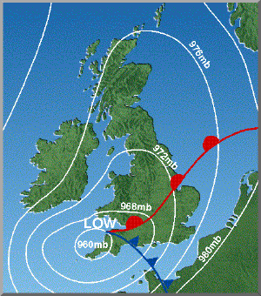
Source 1

Expected climate change in the UK – more gales
The great gale of 1987 created havoc over SE England. This was followed in 1990 by a storm of even greater intensity.
*The question arises are the frequency of these storm events increasing?
*Are the civil authorities geared up to cope with:
a) the immediate effect of another event and
b) the needs of communities after such events?

Expected climate change in the UK – more floods and erosion
“Even small increases in mean sea level, combined with a modest increase in wind speed and wave height, could result in a significant increase in damaging storm surges.” (Source 2)
* Can we afford to and, how practical is it to protect the whole of the UK lowlands which are at risk?

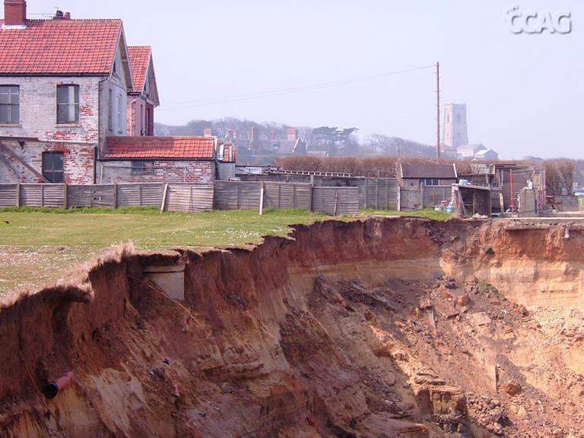
Source 3

Expected climate change in the UK – more extremes of temperature
Some predictions suggest that the daily the winter temperature could fall to as low as -10°C (Source 4) This would cause serious disruption of our infrastructures.
* Consider the impact of 5 days with a maximum temperature of -10°C.
* Examine the effect of the 2003 heatwave on France – what may be the impact of such an event on the UK?

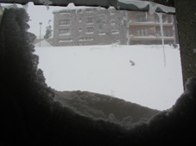
Source 5

Expected climate change in the UK – Farming
The agricultural patterns will change. Climate change will impact on agricultural pests, disease and cropping patterns. Higher seas and stronger winds will result in salt spray being carried farther inland (salinisation), which will effect soils and groundwater supply. Demands of people will change (indeed people’s taste may change).
* Draw up as many positive natural and economic effects of climate change on UK agriculture.

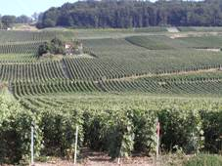
Source 6

Expected climate change in the UK – Health
There appears to be a potential for an increase in waterborne diseases. Of 25 serious waterborne diseases listed (Source 7) there appears to be no recent demographic change in those diseases in the UK that can be related to climate change.
An increase in toxic blue green algae, improved climatic conditions for malarial and other water based diseases will demand changes in research and monitoring.

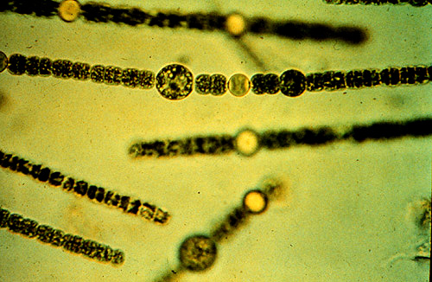
Source 8

Expected climate change in the UK – the Economy
“Claims (insurance) for storm and flood damage in the UK have doubled to over £6 billion over the period 1998-2003, compared to the previous five years, and this figure is expected to triple again by 2050.” (Source 9)
Loss of earnings, loss of potential business may, at the very least, have significant short term impact on the UK economy.
* Would climate change represent a loss to the economy or a change in direction?
* What potential economic growth areas would occur in the UK economy as a result of climate change?

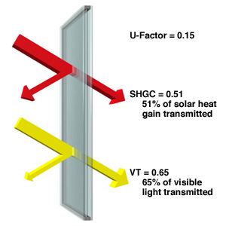
Source 10

Expected climate change in the UK – Carbon Dioxide Emissions
“Royal Commission on Environmental Pollution (RCEP) has said that the UK's CO2 emissions should fall by 60 per cent from 1990 levels by the year 2050. This implies an annual reduction of over 1.5 per cent - this is equal to a 45 per cent reduction by 2030.” (Source 11)
* Is the UK meeting this target?
* Is this target high enough?
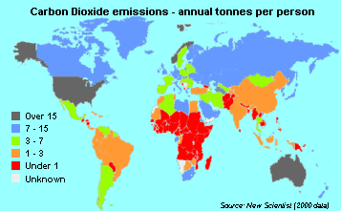
Source 12

Sources
1. http://www.stvincent.ac.uk/Resources/Weather/Severe/oct87.html
2. http://www.rhs.org.uk/news/climate_change/chapter2.pdf
3. http://www.happisburgh.org.uk/gallery/jimw/20052504_4.jpg/view
4. http://www.metoffice.com/research/hadleycentre/pubs/brochures/2005/CLIMATE_CHANGE_JOURNAL_150.pdf
5. Harold Ousby “View from a frozen window”
6. Harold Ousby “Vineyards”
7. http://www.dh.gov.uk/assetRoot/04/06/88/77/04068877.pdf
8. http://cal.vet.upenn.edu/poison/plants/slides/s005lg.jpg
9. http://uk.biz.yahoo.com/moneyweekly/climatechangeandmoney.html
10. http://www.efficientwindows.org/glazing_.cfm?id=9
- http://www.foe.co.uk/resource/press_releases/20021129120015.html
- http://www.nef.org.uk/energyadvice/co2emissionsctry.htm

