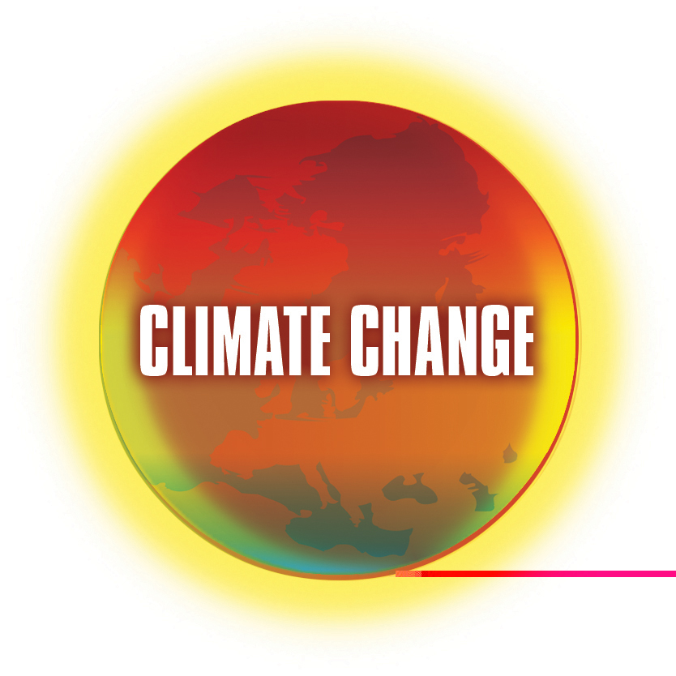 | Climate Change in the Curriculum  WMnet’s major activity in 2005-6  http://climatechange.wmnet.org.uk

The WMnet Climate Change in the Curriculum programme is designed to encourage and support teaching and learning about climate change during the school year September 2005 to July 2006.
The programme is a set of activities and projects linked to the theme of climate change that increase the use of broadband technologies and foster new ways of teaching and learning.
The resources that emerge from these activities will be freely available to the UK education community under the WMnet Climate Change in the Curriculum banner.
The programme will be launched with a conference for teachers on 13th October, organised in partnership with Tide~ (Teachers in Development Education):

A climate for change -
schools and sustainable development

Day conference at Millennium Point, Birmingham
Thursday 13th October 2005

This event launches new initiatives and opportunities on climate change and sustainable development.
For more information and how to register go to http://www.tidec.org

Why climate change?
This programme of work coincides with the UK’s chairing of the G8 group of countries and presidency of the European Union, for both of which the prime minister has made sustainability and global warming a key issue.
Young people are rightly worried by stories about global warming (some of them conflicting) and its impact on the environment. They look to teachers to help them understand the evidence and issues.
There are potentially many opportunities to cover the topic in a range of subjects. The topic can also be a stimulus for innovatory practices using broadband technologies in teaching and learning.

What will be achieved?
The aims of the programme are to:
- Enable schools to provide opportunities for teaching and learning about all aspects of climate change
- Help develop pupils’ information literacy e.g. to distinguish between fact and opinion
- Provide a stimulus for collaboration and partnership between schools in the region and beyond
- Create and sustain links between scientists, particularly those in the region, and learners
- Help change learners’ perception of school science such that science is seen to be more relevant
- Exploit the potential of e-learning and technologies that make use of broadband connectivity
- Develop curricular resources and learning objects of national relevance and utility.


Curriculum links
Activities are intended to impact on the school curriculum in the following areas:
- Science – data capture and interpretation, physical processes
- Geography – weather, environmental change
- Citizenship – research and debate topical issues
- RE – ethical issues
- ICT – internet searches, interpreting and evaluating information, monitoring changes
- Literacy – judging the reliability of evidence, spotting bias, persuasive writing
- Mathematics – data handling
- Modern Foreign Languages – debates with peers in other countries and the topic of the environment
- Sustainable development – discussions of solutions

Activities for schools
Curriculum mapping. Mapping climate change activities onto the national curriculum will coincide with a review of the QCA model schemes of work in science and geography, beginning at Key Stage 3, which highlights areas where climate change issues are relevant and appropriate.
Web-cast and broadcast debates from the Young People’s Parliament to facilitate the debate over the ethical issues surrounding the global warming hypothesis.
Links to meteorological web-cams, monitoring equipment and databases providing live data feeds, including providing data and video feeds from environmental centres in the region. There will be opportunities to share climate change data through GIS systems.
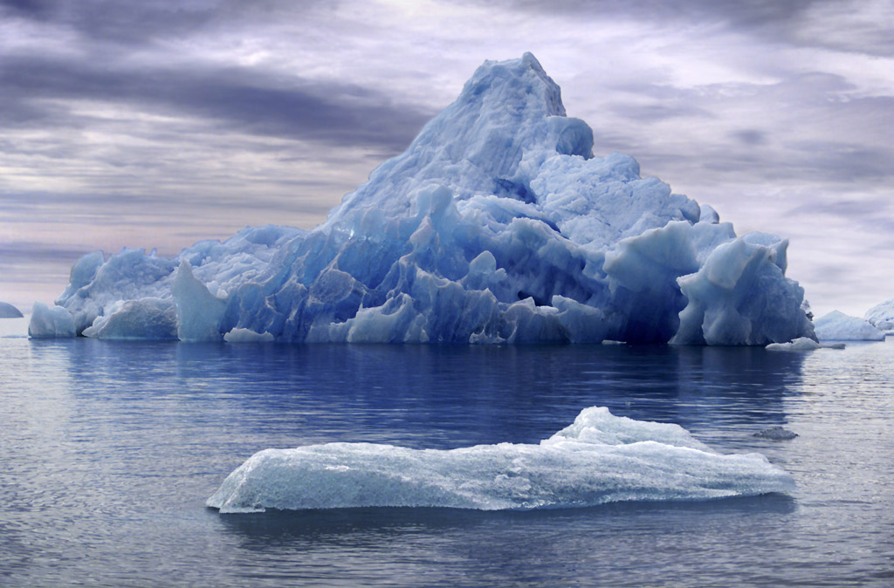
Support for international collaboration between schools over climate change, using video technology in the communication of the experiences surrounding climate change and to explore national variations in the perception of the threats from climate change, e.g. Caribbean, Bangladesh, Europe.
An inter-school collaboration project that encourages schools to work together.
Topical activities, e.g. ‘spring watch’ supported by on-line community tools for school collaboration.
Live, video-conference, on-line ‘ask the expert’ sessions during which academic experts from the West Midlands and beyond answer questions from learners in schools.
Email forums. Expertly moderated and answered online forums for schools on Global Warming issues.
Climate modelling tools and animations. Interactive on-line simulations of global warming and the consequences of climate change with scope for students to vary the models, assumptions and premises.
Feedback Forum. There will be facilities that encourage learners to indicate their response to the materials and initiatives plus their recommendations for improvement.
All the WMnet funded activities in this project will be made available on-line through the WMnet climate change portal.

Other activities
Climate change portal. A section of the WMnet portal draws together links and publicises the activities, also acting as a gateway to other climate change resources mapped onto the national curriculum and strategies.
Teacher and adviser panel (in partnership with subject associations) to identify and review useful resources, sites and links, mapping them against national curriculum subjects to encourage embedded work on climate change in a range of subjects.
New pedagogical models. One or more projects will explicitly develop innovative pedagogies, notably enquiry based learning.
Monitoring and evaluation. A process of evaluation will be built into the programme from the planning stage onwards. It will assess the impact of the activities on schools continuously throughout the school year and into the following academic year.

Partners
The programme is WMnet’s contribution to the growing number of national initiatives provided by the ten Regional Broadband Consortia. Close links will be developed with public sector and commercial partners in and outside the region, including:
- Tide~: Teachers in Development Education, Birmingham
- Birmingham University Department of Geography, Earth and Environmental Sciences
- Bishops Wood Environmental Centre, Worcestershire
- Lancaster University
- Subject associations, e.g. Association for Science Education, Geographical Association
- GLOBE
- European SchoolNet, Brussels.
It is WMnet’s intention to continue work beyond this initial phase subject to funding and support.
If you would like to contribute to the work in the Climate Change in the Curriculum programme please contact info@wmnet.org.uk.

