e-Learning in action
Using an online teaching platform in Coventry
www.wmnet.org.uk

All schools in Coventry are linked to a broadband backbone and a number of the schools have been involved in piloting the Gradepoint teaching and learning environment. This case study, based on work by Don Passey of Lancaster University who observed the system in use, describes how the system works, the different learning settings in which it has been used and analyses the views of teacher and learners who have used Gradepoint.

How Gradepoint works
Gradepoint (www.gradepoint.net) is an online teaching and learning environment. Using it a teacher can teach pupils simultaneously in a number of locations. The system works by the teacher speaking and learners listening through headphones. Student responses are made in written form and everyone can see everyone else’s. The teacher can provide resources like texts, images, presentations and links to web pages. The teacher can use the features to elicit responses in a range of ways, for example, learners might give a text response, use the cursor to draw or annotate, or select from a list.

Gradepoint in use
Both primary and secondary schools in Coventry use the system, as well as adult learners and the hospital and home education service.
Subject | Course level | Topics covered
English | AS level | Philip Larkin Poetry
English | GCSE | Poets from Anthology
French | GCSE accelerated group | A selection of lessons
ICT | Applied ICT | A selection of lessons including revision
ICT | Entry level | Introductory lessons
ICT | European computer driving licence (ECDL) | All 8 modules of the course
Mathematics | GCSE accelerated group | Series of lessons
Spanish | KS2 MFL project | Series of lessons
PSHE |  | Lessons to build confidence
Sociology | AS level | Unit 1 Family & Society & Unit 3 coursework

The system enables a teacher to run a lesson via an on-line environment, where some pupils may be present within the teacher’s room, while others are in a more distant location. In one year 9 lesson, some pupils were in a hospital school, some were in a pregnancy unit and others in a medical recovery unit.

Whatever the grouping involved, experience has shown that there is a critical need for lessons to be created in advance.
When logging into the system, the tutor can select a number of parameters, which determine features of the session and how it can be run. For example, in one lesson, a teacher selected an audio and slide show, selected the subject and the elements to be used, but turned off the pupil annotation feature. The slides for the session were loaded up, and a green light was shown when these were active. The slides offered pointers about how to undertake coursework, on how and what to write. This session was the fourth session of four on aspects of coursework. The slides on the system remained in an archive for pupils’ access later. Pupils worked with individual headphones – and in this school they were numbered for each of the 24 individual pupils.
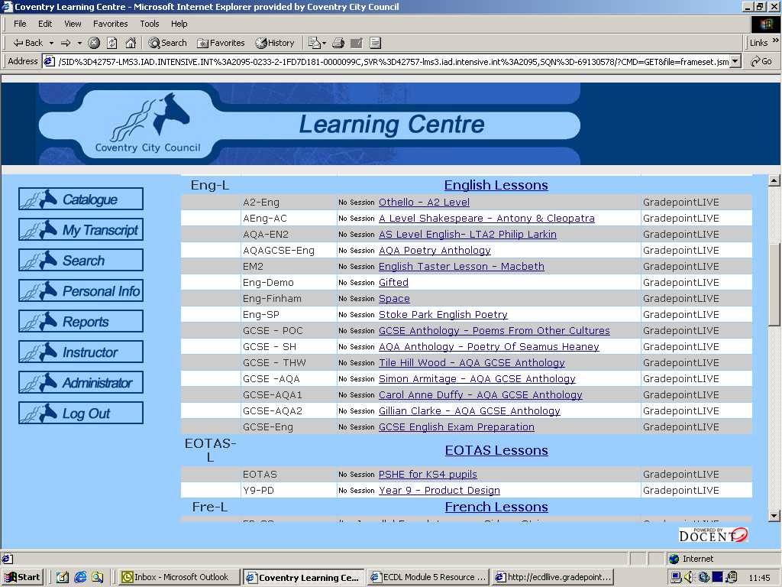
Coventry’s Learning Centre home page
One project was run for primary schools that involved training a group of students from Spain. The students, who came from the Zamora Institution of Education, were trained in Coventry. A set of lessons was developed that could be delivered to year 4 and 5 pupils in the schools in Coventry in which they were working. The primary pupils indicated that they very much enjoyed on-line learning, and were not shy when it came to using a microphone. The intention was that the students would continue to run lessons when they returned to Spain. A number of lessons were run, which involved pupils in schools in Coventry being taught by a teacher in Spain.
The environments in which pupils work in these sessions have varied. A lesson in one school, which involved five boys and 14 girls, was run in a computer suite, for example. The computers were arranged in banks, with some space around the workstations for writing, but the room was fairly crowded, although it was air conditioned. By contrast, another lesson involved a teacher in one school location, with 11 other ‘students’ involved, five at the Elm Bank LEA Centre, and six at other locations. The system works without it needing to rely upon video, but not just on textual communication either, as a teacher can pass a microphone to a pupil in a class so that the pupil can, for example, explain a problem that has been encountered. However, this microphone facility has not been extensively used, often because pupils become shy when using this medium (and that includes adult learners). A lot of use of a microphone facility could also potentially slow down the pace of a lesson. A new feature of the Gradepoint system is being developed allowing participants to take part in a two- or three-way conversation, but use of this facility requires some skill to ensure that pupils are not all talking at the same time.
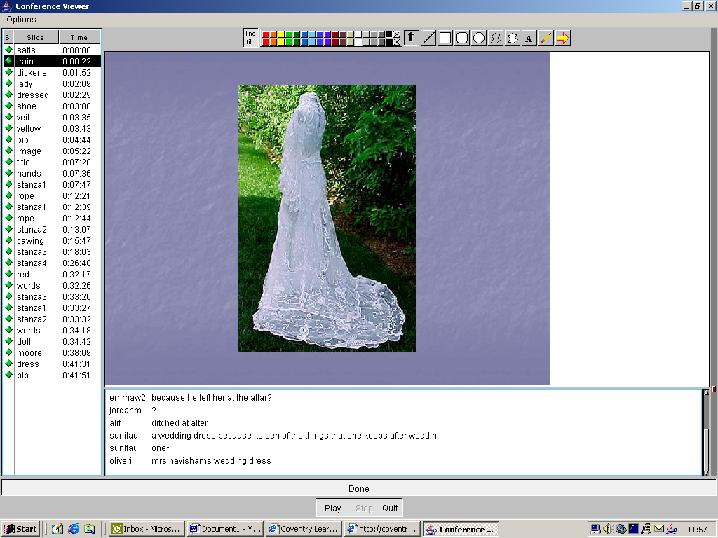
Teaching points can be enriched with illustrations
The system can be accessed by pupils from home. Many pupils have accessed the resources that are archived in the system. Some pupils have cable access at home, and they have logged in to lessons when they have been absent from school. Pupils can in this way continue to work with a group even though they may not be physically present.

Broadband added value
Teachers have been willing to pilot Gradepoint in part because of their increasingly positive experiences with broadband access. Performance is recognised as reliable, and earlier technical issues have been resolved. Although network issues can arise, teachers know that these are resolved fairly quickly.
The access to images via broadband has been felt to offer an enhanced learning potential. The reasons for using Gradepoint have varied, but teachers have reported that the use of images, slides that reinforce key points, and materials that can be referred to more often than handouts, are all seen as being positively beneficial. Pupils are able to access archive material, and the system provides this archive facility integrally. In some cases, it is found that perhaps 25% of a class will access material at home regularly, after it has been used in lessons through Gradepoint. Access to material is also made by pupils when they are absent, and lessons can involve the same group of pupils even though some might be at home or located in different distant locations.
Key aspects that determine ease of use of the system include:
- Definition on screen is important, as blurred text and images can be off-putting.
- Pace is particularly important, so use of a variety of resources can aid pace.
- The audio aspects are particularly important. The teacher needs to speak with enthusiasm. Teachers’ verbal comments on how well pupils are responding help to maintains pace and involvement.
- Teachers maintain engagement by generating discussion with text responses, rather than merely providing questions that have to be answered. Use of text responses to generate discussion maintains an increased pace and interest in lessons. Asking questions rather than generating ‘discussion’ reduces interest and a focus on learning. The responses provided by pupils are shown against their names, so those not involved can be identified by the teacher.
- If pupils encounter problems, they can ‘request the mike’ – which is an equivalent of them putting their hands up. But experience has shown that when a teacher passes the microphone they usually do not then want to speak.
- There is also a ‘whisper’ function, so a pupil could ‘whisper’ to the teacher to say that they did not understand, for example. Again, experience shows that this facility is used mainly when pupils want to whisper to one another. It has been used by some teachers to form small groups within a class 'whispering' with one another to form a view before reporting back to the class.

User views
Learners have been enthusiastic about Gradepoint. For example, in a year 12 AS English lesson about a Philip Larkin poem led by a teacher who was experienced in the use of this medium (having been involved in its use since October 2002), the observer noted that the depth of discussion was enhanced, pupil responses were more considered and timed questions encouraged more rapid thinking. The students in the class gave a range of positive views:
- “You all get to have a say and your views are looked at individually, whereas in a classroom they all sort of merge together”
- “You get a good range of other people’s ideas. You see other people’s views while giving yours as well. Getting to see everyone’s views gives a wider understanding of the poem – looking at it from all angles.”
- “You ask good questions and answer without feeling shy. If you have a view on a subject you don’t feel as embarrassed as if you were in a classroom”
- “It’s good to see other sources at the same time”
- “It’s a more exciting way of studying the poem because we learn together”
Some pupils said they preferred using Gradepoint to traditional lessons in classrooms. For example, one pupil said that she benefited from seeing the slides as well as hearing about them, that handouts were filed when Gradepoint was used, that she tended to look at the slides more than the handouts, and that the slides were more focused (as they offered specific points, while there was usually more text in a handout).
However, not all pupils respond in the same way to this medium. In one lesson observed, for example, pupils did not focus well in the lesson; they chatted to each other about their weekend social activities, or used email, or even mobile telephones. Indeed, part of the Gradepoint system encouraged general social discussion between pupils, rather than keeping them on task. Another pupil said that Gradepoint was hard to understand and lacked interaction; he was frustrated that he could not speak to the teacher and that points were not explained enough.
Successful use of the Gradepoint system by teachers was associated with certain key points:
- The teacher introduced all the pupils involved at the outset of the lesson.
- Clear aims were set at the beginning of the lesson. Knowing at the outset that pupils would be assessed on their levels of involvement was important.
- Pace is set early, and although pupils may have little time initially for answering questions or responding to voice requests via text, within short time periods responding to questions becomes easier as engagement increases.
- The range of resources offered within a lesson by the teacher is important. Use of internet resources, maps, video feeds from web cams, images and text can all be involved, and this range can stimulate engagement.
- The facility allows slides to be annotated, which enables pupils to view the actions of others, and can stimulate engagement.
- Resolution and definition of resources on screen was an important factor, and the teacher needed to choose clear resources.
- Many resources were introduced for fairly short periods of times, which added to the pace of a lesson.
- Text responses generated by pupils could be used afterwards for inclusion within longer texts such as essays.
- Text responses allowed for a discourse with others, without the problem of pupil responses being ‘spoken over’.
- Pupils of different abilities could be assigned different tasks and they could work in different ‘rooms’, which helped with differentiation.
Teachers have stated that they can identify the ability of pupils more quickly by using this system. However, it is clear that this can only happen when pupils are engaged in discussion, so that the teacher can assess both contribution and response. Assessing the level and quality of answers to questions and the level of being involved is an integral part of the teacher’s role. Initially in a lesson that is set with high pace, pupils have little time for answering via text, but pupils can soon pick up the pace of the lesson, and the use of time limits can sharpen the pace of the lesson. Rich media resources can be introduced into a lesson, and slides can be annotated. Internet screens can be brought up, and it is possible for pupils to use a ‘respond’ button in response to items that they see and work on. It is possible to retain screens and then to access different screens from the bottom bar. Text responses from both the teacher and pupils can be retained, and it is possible to incorporate these into an essay, for example. Interesting asides can arise in a text discourse, and these can be used by the teacher to stimulate discussion on a related topic.

The future
Coventry LEA have launched a full roll out of the ECDL programme, as the pilot was judged successful, and Gradepoint is being used to deliver this. This roll out involves something like 360 learners participating in about 32 broadcasts each week. Pupils involved ranged from year 9 to year 12, and the courses also involved a home learner, and adult learners from primary, special and secondary schools. Adult learners included education assistants, teachers, and administration officers. The first group of students to take the course were year 11 gifted and talented accelerated learners. They took the first module tests (on-line) and achieved a 100% pass rate. They were fast tracked through the modules in the time freed up by taking some GCSEs early. They did not have an ICT qualification, and this stimulated their interest in this course. They were reported to have enjoyed the on-line learning environment and also made use of the bank of resources that Gradepoint set up for each module for learning outside of class.
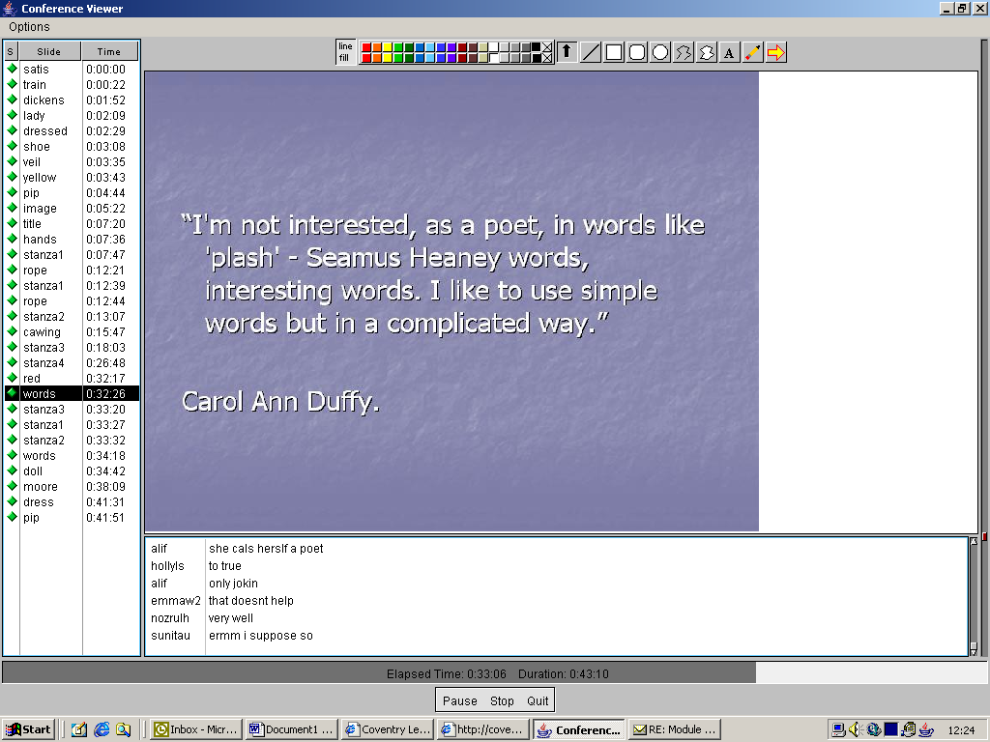
Past lessons can be accessed from home
The success of this type of on-line environment is likely to depend on a number of factors:
- Teachers running lessons need to rely very largely upon their verbal skills in generating involvement and interest, without their being able to see direct feedback always from pupils. Teachers need to speak with enthusiasm and interest even though they do not necessarily have a class in front on them, or any auditory feedback.
- Setting a pace to the lesson, and maintaining pace through use of a variety of resources is a key need.
- Using text responses helps to engage pupils widely. Teachers need to encourage not only responses to questions, but also to add text for discussion.
- This form of distant interactive lesson does not rely upon the use of video. It has been found that video conferencing can be intimidating to some pupils, while they take more quickly to this form of medium.
- The IT capability and typing speed of pupils may be a factor of importance.
- Lessons can be archived and can enable pupils to review and work through the resources afterwards.
- Lessons so far have been used largely for extension purposes, rather than offering core lessons within courses. Extension or enhancement lessons can be run during school or out of school time.
- Numbers of pupils do not limit use, but can determine the type of lesson that can be run.
- Pupils who do not understand a topic or aspect can look for other stimulation, and may be distracted when they use this system.
- The facility where pupils can privately chat to each other can be distractive, and should be disabled where possible.
- Facilities to support those pupils who have their ‘hands up’ because they do not understand or want more explanation, should be explored more.
- Because the use of this environment offers less direct feedback to the teacher, there are likely to be significant training implications.

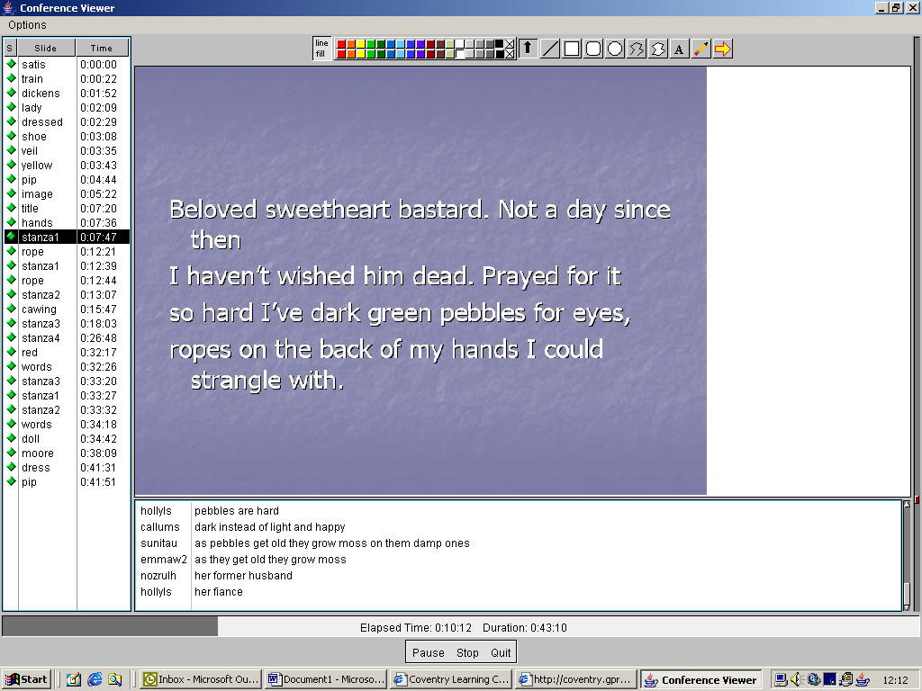
Student responses to a Philip Larkin poem

Key points for e-learning
- Lessons using Gradepoint have been run successfully in a number of subjects, to support a number of courses at different levels.
- Pupils have used school ICT suites and computers at home to access lessons and resources in the Gradepoint system. Home access has involved both use of resources after lessons and involvement in live lessons when pupils are absent from school.
- Teachers’ interest has in part been due to the reliability and quality of the broadband infrastructure. Broadband access ensures that on screen resources are of high quality, that they run quickly, and that audio transfer is of high quality.
- Teachers have reported benefits from the system. Access to images, use of ranges of resources, and access to lesson materials by pupils at home and when absent have all been reported as benefits.
- Key factors that determine whether pupils gain from using of the system include:
- Resources that have a high definition on screen
- Use of resources to aid pace
- Speaking to maintain enthusiasm and interest
- Using text responses to engage discussion rather than merely generating answers to questions
- Picking up on those pupils not involved
- Successful use is associated with features such as:
- Effective planning of lessons in advance
- Pupils being introduced at the outset of the lesson
- Clear aims being set
- Short time limits being set for responses to questions
- Effective use of ranges of different resources
- Using annotation to stimulate engagement
- Having text responses afterwards to include in essays or notes
- Use of different ‘rooms’ to support differentiated activities.
- Some pupils are enthusiastic about the use of Gradepoint, and recognise benefits to their learning. They like:
- Having access to wide ranges of sources
- Seeing the viewpoints of many other pupils, from different schools
- Embarrassment being reduced
- Discussion being more in depth.
- However, other pupils are not enthusiastic, and are concerned particularly about their lack of direct verbal contact with the teacher, and not being able physically to ‘put up their hand’.
- Support and training for systems of this type should in the future cover aspects such as:
- Teacher speaking skills when there is no direct auditory feedback
- Setting and maintaining pace in lessons when pupils are not physically present
- Generating discussion through text responses
- Use of resources for review or reinforcement
- Access to resources beyond lessons
- Involving those who do not understand
- Providing for those who have their ‘hands up’.
It is likely that some of the successes and difficulties experienced by teachers and learners with this system will occur with other learning platforms.

This case study is based on work undertaken by Don Passey of the University of Lancaster for WMnet in 2004.

WMnet would like to thank Coventry LEA and the teachers and students for making the case study possible.

