WMnet Update
News from the West Midlands Regional Broadband Consortium
Issue 6: Autumn 2004 | www.wmnet.org.uk

Video Conferencing Developments
Traditionally video conferencing has been implemented using dedicated ISDN lines. Often there is little flexibility for moving equipment connected to these lines between classrooms, and there are charges for both use and rental.

As schools are connected to broadband links it becomes possible to use IP-based video conferencing systems over these links, with no extra cost or restrictions on use. The actual opportunity depends on the technical detail of the school and local authority network, but it should be possible to use a range of cameras to suit all budgets, from any connected PC in the school.

WMnet is participating in a national project to share video conferencing services with universities and colleges, as well as schools all over England. This includes a central booking system for group conferences and external links to ISDN video conferencing. WMnet is looking for pilot schools that have existing video conferencing arrangements either using IP or ISDN. Contact simon.white@wmnet.org.uk in the first instance.

Single school implementations of video-conferencing are wholly inappropriate; there are issues of compatibility with systems outside the school and support issues. It is imperative that schools wishing to purchase video conferencing systems do so in consultation with their local authority IT support service.

Managing e-Learning in Shropshire
Shropshire Education have adopted the Digitalbrain Managed Learning Environment, providing schools with a set of tools enabling teachers to present packages of curriculum resources over the internet and on the school network. Students are similarly provided with tools that enable them to manage their own learning resources either at home or at school.

The adoption of Digitalbrain as part of Shropshire’s Integrated ICT strategy is timed to coincide with the launch of the Hands On Support initiative. It means that the support team can plan its activities around the resources and tools that schools have adopted, which contributes to an effective and valuable training programme. Wider advisory service involvement, LEA licensing for Logotron School Office and the use of virtual communities further enable sharing good practice and resources. This illustrates the value of schools agreeing with the LEA to use common systems and matches developments in other LEAs using common learning platforms and content management systems.

Crossover
Pupils and teachers from primary schools representing all 14 LEAs in the region gathered together at Enginuity in the Ironbridge Gorge in June to test bridges and vehicles they had been designing and building in Y6 Design and Technology lessons, supported by video-conferencing, email, and online resources and communities. .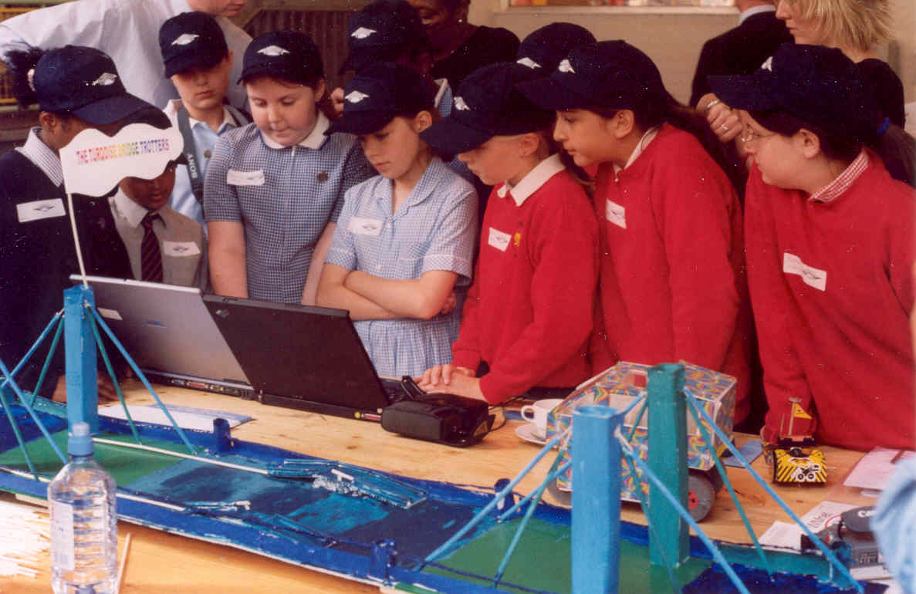

The Crossover challenge required one school to construct a bridge over a river and its partner school a vehicle to carry people over it. In preparation, classes had emailed each other and had online access to experts at the University of Central England, in LEAs and from industry (through Imagineering), but it was only when they met at Enginuity that they discovered whether their buggy and bridge actually performed to expectations. And they did, albeit with a few mishaps!

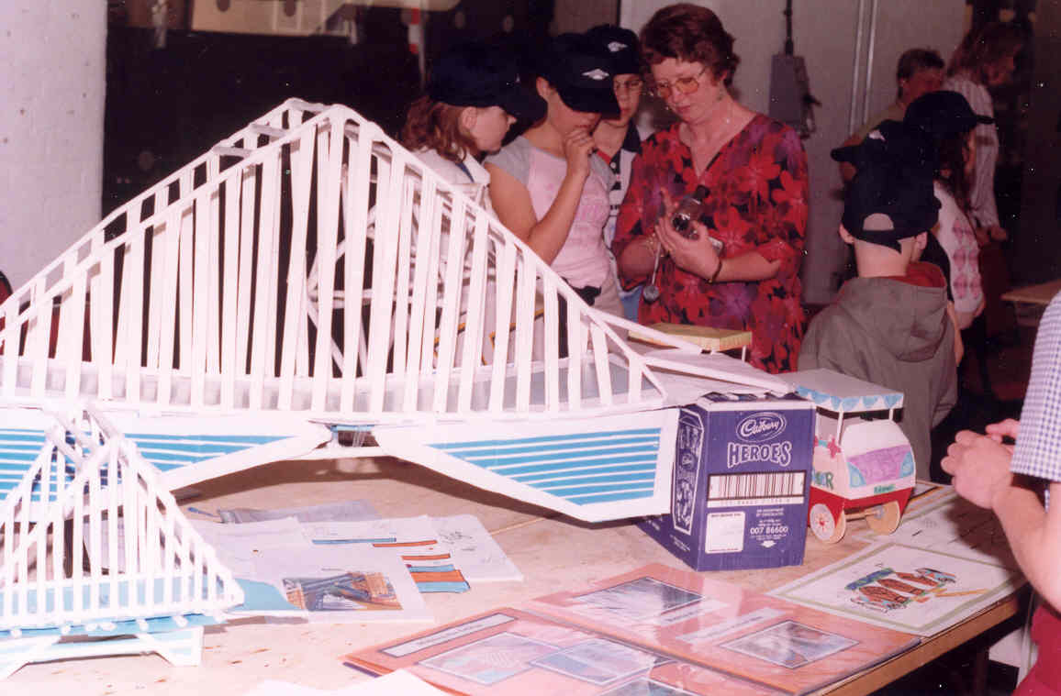

Highlights of the day were captured by new media company c21vox and successfully broadcast over the regional broadband network to participating schools and local authority centres. A similar project is planned for 2005, on a larger scale. More information, including support materials and a project report on the project, is at www.wmnet.org.uk/go/crossover.

Body by the Side of the Road
One week before the end of term is not perhaps your first choice of date to investigate an untried activity with 60 students at two different locations using serious levels of technology. The risks involved were great – would the technology work? Would the children cope and enjoy the activity? The answer to all the questions was a resounding YES! The teachers felt that the children had been enthused and intrigued by the day and, despite the fact that it was so close to the end of term, that they had all been engrossed and on task for the whole time.

Two schools and two City Learning Centres across the region were involved: Wrockwardine Wood Junior school at the Learning Innovation Centre in Telford and Prince Albert JI at Northwest Network CLC in Birmingham. They worked on a Birmingham Grid for Learning activity produced by Kings Norton CLC and used for the past year as a stand alone activity.

This activity is designed to give students the opportunity to develop their thinking skills via detective work. A young man is discovered lying in a ditch. He dies without regaining consciousness. It is the job of the police – and the students – to discover who he is and what happened to him by examining the contents of his wallet.

For this trial the activity was extended and enhanced by the use of IP video conferencing and by using a new product called Macromedia Breeze. This allowed real time interaction between students and the 'cast' at the incident room set up at Kings Norton CLC. Via video conferencing the students were able to ask questions in real time to characters and also via the chat window to ask for additional information. Word files and images were made available at suitable times throughout the activity which added to the feeling that the events were happening 'live'.

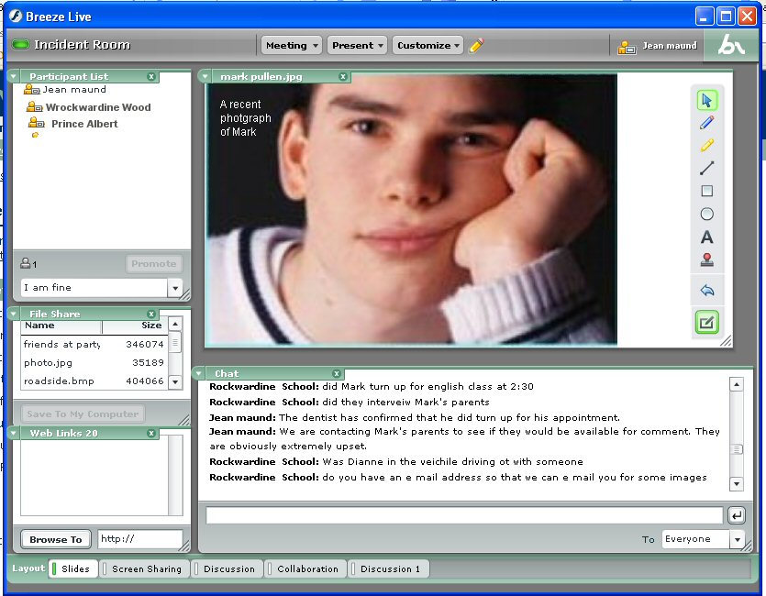
Screen shot from Breeze

Students showed by their level of questioning that they were completely engaged in the activity and were having to think carefully about the best way to 'solve' the problem. It was also interesting to see how the two schools started to interact with each other when the link to the CLC was temporarily 'unavailable'.

It is often said that students are more engaged when aware of an authentic audience. The most frequent question asked of staff throughout the day was, “Is this real?" the students had an authentic audience and they responded magnificently to it.

Similar activities will be taking place later in the year. If you would like to take part, please contact Jean Maund, WMnet e-learning projects manager: jean.maund@wmnet.org.uk.
More: www.bgfl.org/themysteryofthebody.

Embedding ICT
Embedding ICT in secondary subjects is a series of 11 one day DfES events in the regions for Key Stage 3 teachers and curriculum leaders. Planned jointly by the DfES, Becta and subject associations, they aim to support the effective use of ICT in secondary school subjects, as described in the ICT across the Curriculum (ICTAC) pack from the Key Stage 3 National Strategy. In the West Midlands one conference, for numeracy, at the Think Tank, Millennium Point on 23rd November. The full list of subject events, programme details, locations and booking forms can be seen at www.livegroup.co.uk/ICT/index2.php.

Ofsted highlights ICT impact
According to Ofsted, ICT teaching standards have increased in schools, British classrooms now have record levels of IT equipment, and resources compare favourably with other European nations.

The report, ICT in school, the impact of government initiatives, stated that evidence from lessons shows that broadband access can increase pupils’ motivation, improve the pace of lessons and use of time, and lead to better quality outcomes. Broadband enables fast access to a wide range of websites and fast, easy downloading of large files. The report recommended that at a regional level, support should concentrate on exploiting the full educational benefit of broadband, moving the focus away from infrastructure.’
The report is at www.ofsted.gov.uk.

What is WMnet?
WMnet co-ordinates the provision of a broadband regional network for learning for 2,500 schools and other centres of learning, enabling access to high quality learning opportunities, content, services and innovative school management and professional development. WMnet comprises all 14 Local Education Authorities in the West Midlands working in partnership with Advantage West Midlands, the regional development agency.

Contact: info@wmnet.org.uk

