WMnet Update
News from the West Midlands Regional Broadband Consortium
Issue 8: Summer 2005 | www.wmnet.org.uk

Zephyr
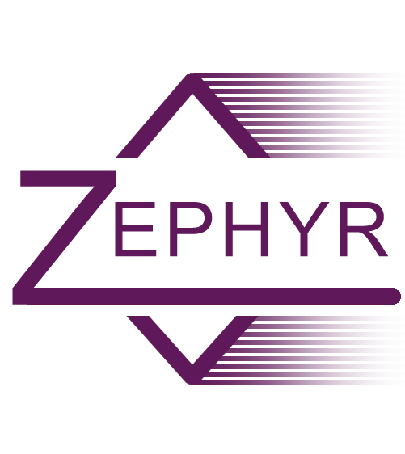
Two training days for 40 key people across 12 authorities provided a very positive start to this pilot project trialling the use of Macromedia Breeze to support online collaboration across the region. A number of e-learning mini-projects have been identified covering a range of curriculum areas. Examples include supporting boys’ writing at Key Stage 2, developing creativity in schools and producing materials for Key Stage 3 science. Collaboration with a number of partners to bring in outside expertise particularly for science and Design & Technology is also being negotiated.

More: www.wmnet.org.uk/go/zephyr.

Crossover II
Year 2 of the successful Crossover D&T project has been launched with a well attended training day held at the University of Central England in March. 28 schools in 14 authorities are collaborating in pairs to produce bridges and buggies to a specific design brief. Some of the schools are trialling the use of Macromedia Breeze for collaboration to tie in with the Zephyr project.

This year, a major focus of the project is on producing high quality Continuing Professional Development materials. Short videos have been made demonstrating how to use hand tools safely as well as demonstrating specific techniques useful in the building of the bridges and buggies.

The CPD materials can be viewed at www.wmnet.org.uk/go/crossoverii. Worksheets and help documents are also in production and will be available shortly.

Beyond Pathé
This innovative project has at its heart four elements;-
- A 'distillation' of the fantastic but huge Pathé archive with particular reference to WWII and will include curriculum support materials written by expert practitioners.
- A number of short high quality films, inspired by the archive material, made in schools with the support and encouragement of professional film makers.
- A series of web casts which will involve experts and specialists interacting with students.
- An online art gallery of work produced in response to the Pathé archive source material.

All materials produced will be freely available from early June at www.beyondpathe.org.uk.

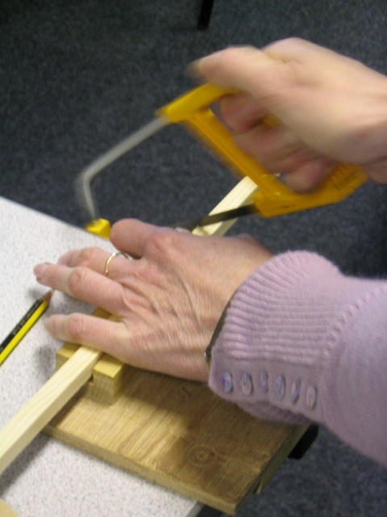
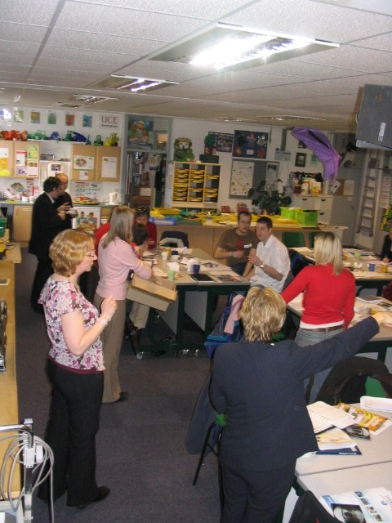
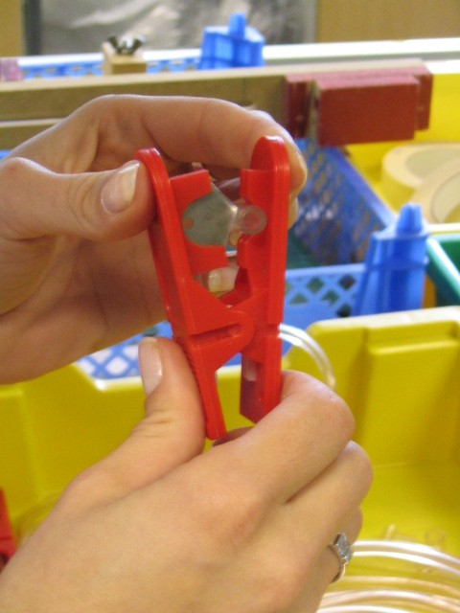

The official launch of the project takes place on the morning of June 8th and features Carl Chinn MBE, well known local historian and passionate Midlander, interacting via video conferencing with schools and students around the region. Four schools in Dudley, Coventry, Warwickshire and Birmingham are involved in making the short films – dealing with evacuation and propaganda – and they will be talking about their plans as well as gaining inspiration and guidance from Carl.

This project is being managed by OSBD media charity. If you would like to get involved with any of the elements of this exciting project please contact Jean Maund (jean.maund@wmnet.org.uk).

Interactive whiteboard resources
Thanks to teachers in the region and the co-ordinating effort of Brett Laniosh, Dudley Grid for Learning, 20 sets of free interactive whiteboard activities are now available on the WMnet portal, for example:
- Mathematics: Clock face with animated hand movement, Developing formulae with Excel, Dividing by zero, Irregular shapes, Measuring length, Reflections, Two random numbers
- Science: Six KS4 activities, 12 KS2 activities, Trees, What rock am I?, Chemical reactions, Formation of crude oil; Fractional distillation; Industrial uses of enzymes; The atom; and Halogens and periodic table.
- D&T: Control resources
- RE: Creation challenges
- ICT: Data handling
- Eating for health
- Literacy: Phonics, Literacy Hour resources
- Templates, e.g. Ten linked pages, Euro shopping, Romans.
Files use a range of formats, including Microsoft PowerPoint and Smartboard format. More: http://www.wmnet.org.uk/go/iwb.

DiDA
The Diploma in Digital Applications (DiDA) is a suite of three paperless qualifications from Edexcel that focuses on the practical application of technology, designed to stimulate students' creativity and develop real-world, practical skills.. DiDA qualifications prepare students for the real world of work or further education. They are designed to stimulate students' creativity and develop real-world, practical skills that will motivate learning across a wide range of subjects. As a suite of qualifications, DiDA offers progression from the Award (AiDA), which is equivalent to one GCSE, to the Certificate (CiDA), and on to the full Diploma (DiDA), equivalent to four GCSE's.
North Western Grid is committed to a very substantial development of DiDA support resources which will be available free to all UK schools and offer substantial savings to all secondary schools. Brochures are to be sent to all local authorities over Easter 2005. Already 80% of schools are reported as intending to use it and Unit 1 content will be ready in September 2005.
WMnet and the other nine Regional Broadband Consortia are supporting and contributing to DiDA, through hands on support and resource provision.
To take advantage of the offer and implement DiDA, learners will require access to e-portfolios. An e-portfolio for all is an essential part of personalised learning under the recently published DfES e-strategy.
DiDA is about creating public assets. All content is open source and SCORM compliant, ‘disaggregable’, and can be reused. Content will set an example to learners and model what they themselves are expected to create.

Digischool
Digischool 2005 is a programme of digital communication activities and events designed to support and extend the use of digital technology across the curriculum for teaching and learning. Developed specifically for West Midland schools, the Digischool programme draws on a variety of digital tools and e-resources, to offer teachers and pupils a set of engaging and creative activities in which to participate. There are three elements to Digischool: Digiteach, Digitalk and Digistory.
Activities include the Rock Idol and Digital Storytelling competitions as well as various curriculum focussed events throughout 2005. There are also opportunities to drop in on a Red Sea coral expedition, online lessons and trying your hand at teaching using the latest video conferencing equipment.
More: www.bgfl.org/digischool.

Empowering Learners with ICT
Two one day regional conferences for teachers, head teachers and local authority staff feature a major presentation by internationally renowned American education innovator Alan November (www.anovember.com):

8th June: National Motorcycle Museum, Solihull
9th June: Copthorne Hotel, Merry Hill
Cost: £90, including a free copy of Alan November’s book. Further details: http://www.wmnet.org.uk. Registration: http://www.rm.com/wmnet

Video-Conferencing the easy way – at last?
The DfES-funded Video-Conferencing Services Pilot enables schools connected to the National Educational Network to video-conference reliably and at no cost. The pilot is managed by UKERNA, who provide JANET, the UK’s National Research and Education Network (NREN), for the university and FE colleges sector. Each country in Europe has its NREN and many are in the process of providing broadband connections for schools to the network. One benefit of this is fast, reliable, safe and affordable video-conferencing between schools, universities, research centres throughout Europe and beyond. Because the communication uses Internet Protocols, there are no usage costs, unlike ISDN video-conferencing. To take part in the pilot, schools should contact their local authority ICT support service and register with the support desk at www.jvcs.ja.net/schools.
WMnet was represented at a seminar in February 2005 organised by the Trans-European Research and Education Networks Association (TERENA) on the subject of connecting schools to the European education and research network via the NRENs. Following this WMnet are testing video-conferencing links over the network between schools in various West Midlands local authorities and Slovenia to demonstrate that the system works from a non-expert users’ point of view.

